August 2016
Content Due:
July 29, 2016
Distribution Date:
August 19, 2016
Issue Focus:
Networking
Items to Include:
President’s Message
Member Services Report
Eastern Region Report
Western Region Report
Central Region Report
Southern Region Report
Welcome New Members
Board of Directors
Articles to Feature:
2016 Conference Highlights
Social Media
Highlight 2017 SITE Socials
(how to host one in your area)
Storytelling

Issue Focus: Networking
President’s Message
By: Deborah Davenport
If I had a dollar……….
If I had a dollar for every time I have heard someone say one of the greatest benefits of SITE membership and/or attending a SITE Annual Conference is NETWORKING…… well yes…..I’d be rich!
This year I attended my fifth SITE Annual Conference and am still in the process of following up on the many new connections I made this year in Minneapolis. Partly it is because I have had a hectic travel schedule since then, but it’s also because I made more personal connections through networking this year than ever before, so it’s taking a little more time to follow up. This year’s exceptional conference program allowed more time for attendee networking and also included an excellent session for attendees to interact with folks from their own Region. Thank you to Elise Quadrozzi and her fantastic Conference Committee for a very successful conference! Networking Rocked!
Why is SITE networking so important to an insurance trainer/educator?
Networking (net-wur-king) noun. a supportive system of sharing information and services among individuals and groups having a common interest.
SITE is the only training organization that has a common interest of INSURANCE! Yes there are other training associations, but no others that speak ‘our’ language. Some may say ‘training is training’, but we know differently. We are able to share tips on how to make legal policy language training fun or how to utilize role playing for claims negotiation training or how to use scenarios for risk management and underwriting training or how to use games for product training or what latest technology could be used at your company. And oh so much more!
I believe the size of our programs and activities is especially conducive to networking. I’ve attended large conferences with other organizations and barely made connections with a handful of people. There were so many attendees that I rarely saw my ‘connections’ again during the sessions and was unable to truly network with them. In fact, I wouldn’t even consider them networking connections. On the other hand, at the SITE conference, I made some great new connections during a break and then ended up sitting next to a couple of attendees in multiple breakout sessions……and then sat with them during a meal, and ran into them again in the Exhibit Hall. These multiple opportunities to interact allowed us more time for in-depth conversations and the ability to share information. THESE are true networking connections that will last. I still keep in touch with people I met at my first SITE Conference AND with fellow Train the Trainer attendees from 7 years ago. We have shared information, problem-solving, job searches, and personal triumphs and challenges unique to our industry.
I encourage you to get involved in your Region with workshops and huddles, attend SITE webinars, attend SITE’s Train the Trainer, and of course attend the Annual Conference. These are opportunities to network with folks of the most COMMON INTEREST……..INSURANCE TRAINERS.
If you are interested in becoming more involved in SITE and have no idea what you could do or how to get involved………just email me or call me……..I’m sure I can help you find something that would be perfect for you! I’m sure because networking works……… we have the support system to hook you up with someone that could utilize your talents on their team or committee!
Deborah Davenport, CIC, ITP
SITE President

Train the Trainer
Train the Trainer ROCKED the house in Minneapolis!
Christine Marciano, Joan Quagenti, Barb Gavitt – TTT Facilitators
Ya gotta love a party that starts early! That’s what Train the Trainer does for SITE’s Annual Conference. We got the conference party started early and kept it going all weekend long!
We totally covered all this:
- Created a forum for active discussion of the content in the online portion of the program
- Created the environment to discuss, then apply, best practices for:
  - creating audio visuals and learning aids
  - creating quality classroom activities
  - dynamic face-to-face presentations
  - successful facilitation of learning
- Offered and received constructive feedback on a semester project and presentation skills
Let’s look at the fabulous folks that are refreshed and rejuvenated, and ready to continue to hand-to-hand combat that is adult education.
(Left to right) Back row: Jeff Denly (Guide One Insurance), Jafir Young (Markel Corp), Josh Hulling (Guide One Insurance),
Middle row: Ashley Tharp (Wright Flood), M’Lissa Peters (Germania Insurance), Janice Mickan (Texas Windstorm Insurance Association), Joyce Armstrong (Guide One Insurance), Sonia Craig (Texas Windstorm Insurance Association), Merry Miravet-Irby (Crawford & Co.), Kimberly Mouw (Guide One Insurance), Barb Gavitt, ITP, SILA-F, TTT Faculty (A.D. Banker), Joan Quagenti, ITP, M.Ed, TTT Faculty (Liberty Mutual),
Front Row: Dorothy Damato (Crum & Forster), Kim Gilbert (Bouchard Insurance), Monica Salmons (Missouri Employers Mutual Insurance Co.), Lain Ahrens (Guide One Insurance), Angela Kain (Secura Insurance), Elisabeth Sobczak (i-Car) Christine Marciano, CIC, ITP, SBCS, CLCS, TTT Faculty (Nationwide)
Several of these brave folks have applied for their ITP (Insurance Training Professional) designation.
What’s the ITP, you ask? We are so pleased you’ve asked. The ITP is the only insurance training designation available (at least that this author knows…) The ITP requires several industry check points. 10 years in the industry, 5 years in training, and an educational component. There are several ways to achieve the educational portion. The coolest way is an online semester that culminates in a live 1.5 day session. The course costs $900. for SITE members.
Interested in attending TTT? The last one for 2016 is Nov 2-3, Chicago – Hosted by Allstate (registration deadline Aug 1st)
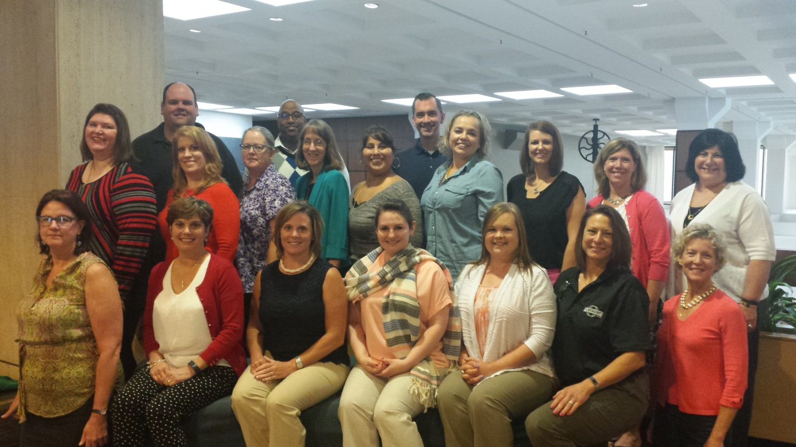

Eastern Region Report
By: Evelyn Jorgensen
Greetings fellow Eastern Region SITE Members!
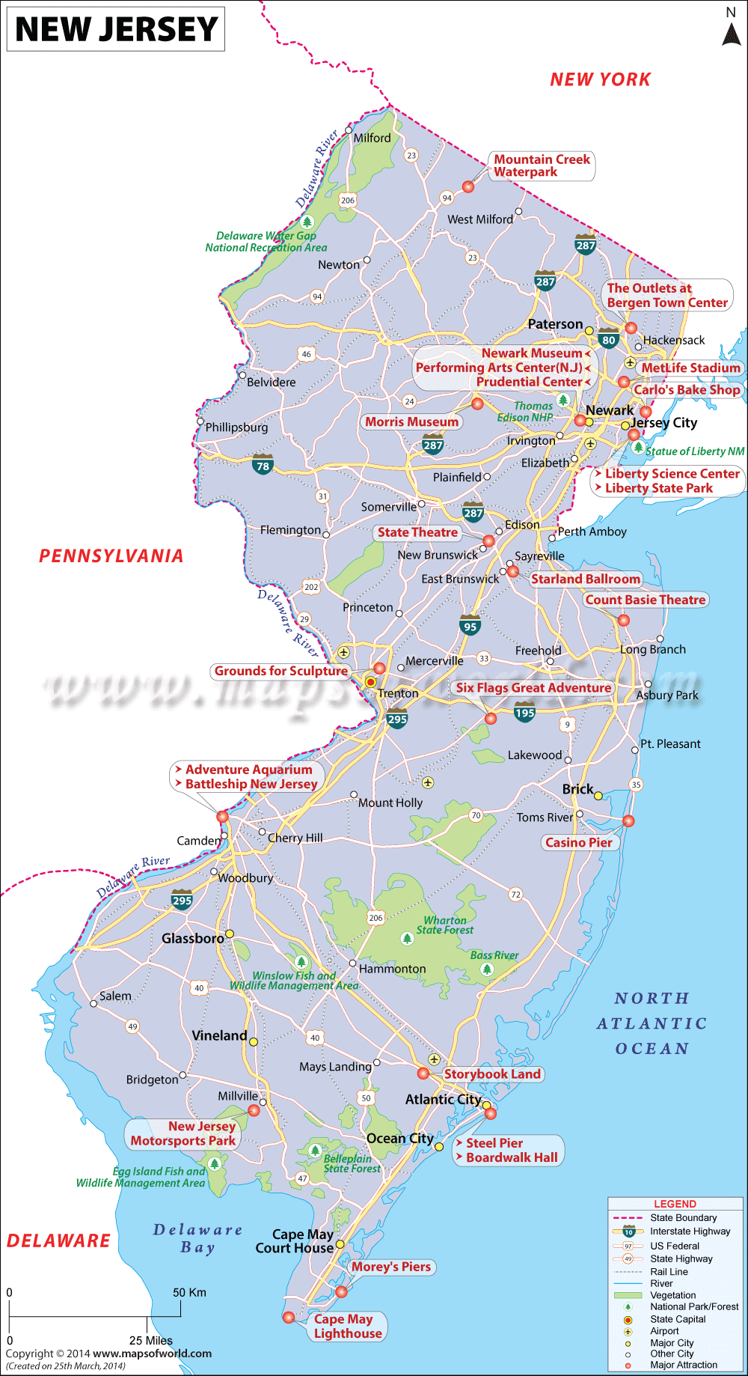
After the picture of the bears in my backyard in last quarter’s InSITE, I know you are all now envious that I live in New Jersey. We may be a small state, but nearly all of our borders are surrounded by water (we are technically a peninsula!)…which means a lot of opportunity for summer fun. You can take the jughandle off of Exit 98 on the GSP to head down the shore (Jersey speak). Or enjoy a canoe/raft/kayak trip somewhere down the Delaware River. We have beaches, rivers, mountains, and even the Pine Barrens (watch out for that Jersey Devil though). Whatever you do in Jersey, you’re likely to have fun. The fact that we’re small makes it pretty darn easy to get together with friends and family just about anywhere.
Speaking of getting together, we had another AMAZING conference in Minneapolis where we got together with our old and new SITE friends. Many of you participated in our Eastern Region meeting – and WOW, did we get some great ideas and feedback for our 2016/2017 year! It seems like our SITE Huddles were popular, and we plan to continue them. Also, folks seem to like the post- Huddle Quick Cards to summarize the key points, even if you weren’t able to attend the live Huddle. The group generated many of new ideas as well. The next question becomes: How can each of us… as a SITE region member… become involved to help perpetuate the fantastic learning, networking and ideas that were generated? We’ve got lots of opportunities and immense talent right in our backyard… (even if that yard isn’t in New Jersey!). Remember that these are safe places for you to practice skills, gain experience and add to your resume! Would you like to: Facilitate a Huddle? Host a Social/Train-the-Trainer/on-site program? Write an article? Conduct a training session (virtual or in person)? Serve as a state director? Reach out to me at siteeasternregionvp@site.com with what contributions you’d be interested in doing to continue this valuable SITE Eastern Region resource.
Happy Summer!
Evelyn Jorgensen
Eastern Region VP

Western Region Report
By: Dan’l Adams
The Dreaded Afterconferenceitis

You: Wow! That was a great conference!
Associate: Really? What classes did you take? What did you learn?
You: Well…I went to so many…I don’t remember…but they were good ones!
Associate: Did you meet any great speakers or other trainers?
You: I sure did! I can’t remember their names right now though. But they are really terrific people! I learned a lot from them!
Associate: Like what?
You: Lots…I have my notes at home. I just haven’t had time to review them.

Membership VP Dan’l Adams: You get the idea…a perfect, and typical, case of afterconferenceitis. You ran from class to class to pre-dinner event to dinner to an after dinner event to the early hours event to packing and then going home to not having enough time to unpack before you were out the door to go back to work. 2 weeks later, the bags are still unpacked (where is my favorite shirt?) and you haven’t given a second thought to the conference…but it sure was a good one, huh?

Then one day, your associate asks you about it and you have the conversation noted above. If that wasn’t bad enough…but then your MANAGER asks you about the conference…not only for how you will actually APPLY the knowledge, but was it FINANCIALLY worth it to send you this year (let alone whether they will send you or anyone else to next year’s conference!). Here are 3 tips to make the conference even more beneficial than it was:

1. Make an appointment with yourself (twice!): make an appointment with yourself ( put it on your calendar!) and sit down and unpack that nifty satchel you got at the conference that you filled up with all that stuff (Thank You Institutes!)! Throw away all the stuff you really are never going to look at…and put the other stuff in another pile. Look at that pile and find ONE or TWO items that really impress you. “Yes! That’s what I want to look at again!” Now, make that 2nd appointment (put it on your calendar) and review the one or two items you kept. How will you apply them to your current work?

2. Maintain your connections (This was some advice from one of our friends at The Institutes): The biggest challenge after an insurance conference is maintaining the momentum and enthusiasm you had during it. Start by staying in touch with the connections you made. Send follow-up notes, emails and messages to networking contacts and speakers you met.

3. Go the next step: Now that you have experienced what SITE has to offer first hand…go the next step! Volunteer to put your trainer experience to use. Help others! You can start small…but do something! Write an article for InSITE; facilitate a short Webinar; host a local social; sign up to be on a committee for your region (or even a Regional Director) or the next SITE conference. Contact your Regional Vice President. She will be glad to talk with you about what SITE and you can do together!

I’m already looking forward to next year’s conference…but I still want to benefit from my time at Minneapolis…how about you?

Dan’l Adams, JD, RPA, ITP, CLP, CIIP, FCLS, AU, AIC, AINS
Vice-President
Membership Services
Society of Insurance Trainers and Educators

Central Region Report
By: Kate Manthey
Need
Southern Region Report
By: Sherry Moor
The Importance of Networking
Straight off the heels of another successful SITE conference I am reminded of why I joined SITE in the first place. Networking! Yes, the content is rich and rewarding and the tips and tricks I take back to my job are top notch, but networking with my peers is my favorite part of being a member of SITE. I have met many amazing people through SITE. It is so encouraging to know that there are other people out there doing the same thing you do. Networking allows us to bond and share with each other both professionally and personally. The friendships that I have cultivated due to SITE are absolutely priceless. Networking is not always used to find friends (although it lovely side benefit); networking is an essential part of our jobs. Will Kintish, in his book “Business Networking – The Survival Guide” explains 6 reasons why you should invest both time and effort into networking.
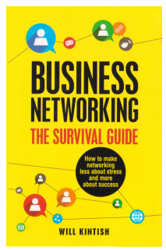
- Networking is not selling: Networking is about spotting opportunities. Spend time asking questions about the person you are talking to and their jobs. Perhaps you can help them solve a problem.
- Networking builds relationships: Spending time on building a relationship could deliver results in the future. Management shows that good working relationships improve the perception of project success as well.
- Networking is expected: Even if your role isn’t explicitly to bring in new business or market the company, you are probably expected, as most people are, to meet new people and understand the marketplace as part of your role.
- Networking is good for you: It is a way to learn more about the business, understand the industry better and hear about challenges faced by your contacts.
- Networking can further your career: Many jobs are not advertised you will need to network to find out about them. People recommend people they like, so while you might not like the person you will be working for in the future you might have met one of their contacts who could put you forward for that dream job.
- Networking is a virtuous circle: If done right, meeting more people leads to more business and career opportunities, which leads to meeting more people and more business, and so on. It might not feel like it now, but you never know what doors are going to open in the future, so it’s worth operating as if that next useful contact is round the corner, as they probably are.
There are many opportunities to network within SITE. You could host a social, host a training event, host a virtual huddle, write an article in InSITE, become a regional director, volunteer, and of course, the annual SITE conference is a fantastic networking opportunity. I hope to network with you in San Antonio, TX next year.

Reference: http://www.girlsguidetopm.com/2014/07/6-reasons-why-networking-is-important/
Networking : A Stimulus for Success
Let’s face it: Relationships are a vehicle for success. In a time when we are all subject to a barrage of media vying for attention, what do we pay attention to? Something from someone we know AND value.
Personal relationships serve as resources. Who do you reach out to when you want information on a specific topic? It’s highly likely that if you know someone who has expertise on that topic, you reach out to them as your first avenue of approach. For me, going to a SITE conference provides a valuable opportunity to meet people who do what I do. I hear new ideas that others have tried or are exploring; we share successes and failures of training initiatives; brainstorming different ideas such as dealing with a new LMS or getting a younger generation interested in insurance. All of this involves networking: developing contacts, building relationships, exchanging information.
But then what ? Do these people just remain in the background until I need them? Is networking simply a matter of one friendly exchange and then using that person as an ‘in’ to fill a future need?
Here’s what I’ve found: As a result of forging my SITE relationships, I’ve been able to continue beneficial dialogues during the year. These people have become valued resources that I can reach out to: sometimes for their thoughts on handling a particular issue; maybe to follow up on something they’ve tried; perhaps for resource suggestions. Preserving that relationship throughout the year is mutually beneficial. LinkedIn is a great way to see what’s happening in the world of your connections, especially when someone updates their status. Sometimes it’s dropping a quick note to follow up , i.e. “Just wanted to say Congrats on [fill in the blank]”. Other times, it’s reaching out to a group of folks that you started a conversation with at conference to keep the momentum going. And sometimes, it’s helping someone else with their need.
Networking isn’t only making that initial connection and then leveraging it when you need it. It’s also about cultivating that connection to create an enduring relationship.

Evelyn Jorgensen

SITE – Three Ways to Network Outside of Conference
I cannot believe another SITE conference has come and gone! I look forward to the conference each year as an opportunity to network with my peers face to face. However, what am I to do during the remainder of the year? How do I to stay in touch, keep abreast of changes, and continue to cultivate and build those relationships that started during the conference? Socials, Huddles, and LinkedIn!
Attend or host a SITE Social, get out there and meet with your fellow SITE members. Invite others in your organization- such as those subject matter experts- who are not routinely involved in training. My company hosted a social after one of the SITE Train the Trainer sessions. I was able to meet new colleagues relatively close geographically. We spent time brainstorming about bringing in the next generation of insurance professionals.
Inconvenient geography is not a factor! My region has SITE Huddles. The Huddles typically take place during lunch and are as easy as dialing in. These sessions are timely and relevant. Topics include Millennials; Onboarding; Setting Stakeholder Expectations. The conversation does not stop after the Huddle ends. We share what we learned with others on our teams, we use the information in our own programs, and we continue the discussion with those who participated.
Social Media is another fantastic way to network. Most of us have a LinkedIn, Facebook, Twitter, Google+, or Instagram account. What a cool way to stay in touch and stay on top of our industry. As members of SITE and members of the LinkedIn page, we can post a question on the SITE page and start a discussion. When I was ‘new to training’, but not new to the industry, I felt awkward. I spoke the correct language, but somehow the message seemed to get lost in translation. LinkedIn to the rescue! Someone in SITE started a conversation by asking: ‘What tools are you using to create your programs?’ I jumped right in and participation was easy. Another time, the conversation started with: ‘Share a lesson learned after a training session’. This was perfect! A way for me to offer out my ‘oops’ moments and at the same time make notes on how to improve as others shared their stories.
SITE Socials, Huddles, and LinkedIn have been a fantastic way for me to be informed, share triumphs, and collaborate. Stay in touch with those you met at conference. Continue to ‘network’, your experience as a SITE member will be richer for it.
Kimberly Levitt

2016 Conference Highlights
It is hard to believe the 2016 Conference is over and done already. What a whirlwind week it was!
I want to again thank my wonderful committee chairs and co-chairs who, in a challenging year filled with change, managed to put together a wonderful agenda and terrific networking events. Our Mississippi riverboat cruise set the stage for a great week as we enjoyed catching up with our SITE buddies while floating down the river, even spotting a bald eagle along the way.
Our opening keynote speaker Amy Blankson kicked us off with a motivating presentation on the power of positive psychology and strategies that will stick and create sustainable positive change. Our panel discussion on the challenges surrounding our aging workforce was lively and thought provoking and our closing keynote, Margi Simmons, along with her Brave New Workshop team led us in an improvisation session that helped us think about how to foster collaboration in groups, creating something that is truly shared and using multiple intelligences – all of which can have tremendous benefit in creating world class training programs. In between were many really terrific concurrent sessions and networking opportunities such as our group walk run event, yoga, coffee runs, first timer’s events and regional breakouts.
Our closing night event with its State Fair theme and terrific food was a great way to unwind after a long week and as usual the dance floor stayed full and lively all evening! Finally, when you thought things could not get any better, our Risk Management tour of Target Field was, by attendee consensus, one of the highest rated Risk Management tours in SITE Conference history. The tour guide was so informative and kept the group educated and entertained about all of the various risk management challenges faced by a major ball park.
I want to close by thanking our SITE Sponsors without whom we could not put on this caliber of event.
Our Diamond Level Sponsors
- State Farm Insurance who sponsored our keynote – Amy Blankson
- I-CAR who sponsored our keynote – Brave New Workshop
- Germania who provided all of our AV equipment
- Federated Insurance who sponsored the Presidents Reception, Closing Night event reception and the prizes for speed networking and bingo for 1st Timers
- The Institutes who sponsored our conference bags
Our Platinum Level Sponsor
- Plus Essentials who sponsored our Mobile Conference App
Our Gold Level Sponsors
- Selective Insurance for Printing
Our Silver Level Sponsor
- Haag Education who sponsored our lanyards
Our Bronze Level Sponsors
- Alliant who sponsored printing
- Exam FX who sponsored yoga
Thanks to all who contributed to making this conference a success and looking forward to seeing you all in San Antonio.
Elise Quadrozzi
Marketing VP

SITE is excited to share our new logo!

As we researched, held discovery conversations, and analyzed over the past year, it was important that we let our history guide us.
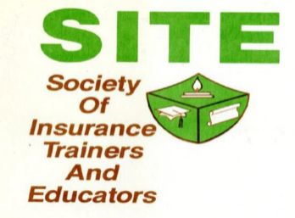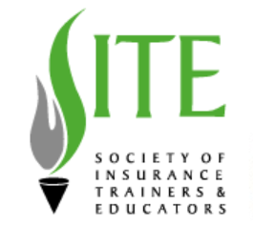
As we defined who we are as an organization and where we envision our future, we analyzed coloring, symbols, even all the way to the type of font used.
Blue signifies trust, security, wisdom, integrity, peace, and loyalty which are all things that our organization stands for. In addition, we continued the representation of the flame, as it signifies a flame of knowledge.
A great logo is an expression of the organization values, culture and people. We are proud to share our new SITE logo!
